1. **Data Science**: Data Science is an interdisciplinary field that combines various techniques, tools, algorithms, and principles to extract knowledge and insights from structured and unstructured data. It involves collecting, cleaning, processing, analyzing, and visualizing data to uncover patterns, trends, correlations, and other valuable information that can be used to make data-driven decisions and solve complex problems.

Key components of Data Science include:

* + Data collection and acquisition
  + Data cleaning and preprocessing
  + Exploratory data analysis (EDA)
  + Statistical analysis and modeling
  + Machine learning and predictive analytics
  + Data visualization and storytelling

1. **Big Data**: Big Data refers to large volumes of structured, semi-structured, and unstructured data that are generated at high velocity and require advanced technologies and techniques to capture, store, manage, and analyze. The characteristics of Big Data are often summarized as the "3 Vs":
   * Volume: The sheer amount of data, ranging from terabytes to petabytes and beyond.
   * Velocity: The speed at which data is generated and must be processed in real-time or near real-time.
   * Variety: The different types and formats of data, including text, images, videos, sensor data, social media posts, etc.

Big Data technologies and platforms are designed to handle these massive datasets efficiently. Some of the key technologies and concepts associated with Big Data include:

* + Distributed computing frameworks like Hadoop and Spark
  + NoSQL databases such as MongoDB, Cassandra, and HBase
  + Data warehouses and data lakes
  + Stream processing systems for real-time data analysis
  + Scalable storage solutions like Amazon S3, Google Cloud Storage, and Azure Blob Storage

**Justify your answer with exmaple , "Data science and big data are the same or different"**

Data Science and Big Data are related concepts, but they are not the same. To illustrate this, let's consider an example:

Imagine a retail company that wants to improve its sales and marketing strategies using data-driven approaches.

1. **Data Science Perspective**:
   * The Data Science team at the company is responsible for analyzing customer behavior, preferences, and purchase patterns to identify key insights that can drive targeted marketing campaigns and improve sales.
   * They collect data from various sources such as transaction records, customer feedback, website interactions, and social media mentions.
   * Using techniques like machine learning algorithms, clustering, and regression analysis, Data Scientists can segment customers based on their buying habits, predict future sales trends, recommend personalized products, and optimize pricing strategies.
   * They also create data visualizations and reports to communicate their findings to the marketing and sales teams for decision-making.
2. **Big Data Perspective**:
   * The retail company generates a massive amount of data on a daily basis, including sales transactions, customer interactions, inventory levels, and marketing campaign results.
   * This data is stored in a Big Data infrastructure, such as a distributed storage system like Hadoop or cloud-based data lakes, to handle the volume, velocity, and variety of data.
   * Big Data technologies enable the company to store and process terabytes or even petabytes of data efficiently, ensuring scalability and performance.
   * Real-time data processing and analytics are supported through stream processing frameworks like Apache Kafka or Spark Streaming, allowing the company to react quickly to market changes and customer behaviors.

In this example, Data Science and Big Data are distinct but interconnected. Data Science is concerned with analyzing data to derive actionable insights and improve business outcomes, while Big Data provides the infrastructure and tools necessary to manage and process large volumes of data effectively.

Therefore, Data Science and Big Data complement each other in the context of the retail company's goal to leverage data for enhancing sales and marketing strategies.

**The 6V's of Big Data**

Big data is characterized by six key attributes, often referred to as the "6Vs." These attributes define the challenges and opportunities associated with working with massive and complex datasets.

1. **Volume:** This refers to the sheer amount of data being generated. Datasets in the terabytes, petabytes, and even exabytes range are becoming increasingly common. Traditional data storage and processing techniques struggle to handle this immense volume. **Zettabytes (ZB)** , GB
2. **Variety:** Big data comes in many forms, not just the traditional structured data (rows and columns) found in databases. It can include unstructured data like social media posts, images, videos, sensor data, and log files. This variety requires new approaches to data integration and analysis. Rows , columns , JSON..
3. **Velocity:** The speed at which data is generated and needs to be processed is another defining characteristic. Data streams from social media, financial markets, and internet of things (IoT) devices can be real-time or near real-time, demanding fast processing and analysis to capture valuable insights. **Mb/s …**
4. **Veracity:** Given the vast amount and diverse nature of big data, with time space and various other compoenets ensuring its accuracy and trustworthiness is crucial. Data quality issues like missing values, inconsistencies, and errors can significantly impact the reliability of any insights extracted. **Accuracy , consistency index**
5. **Value:** Ultimately, the purpose of big data is to extract valuable information and insights that can be used to improve decision-making, optimize processes, and gain a competitive advantage. However, deriving value from big data requires effective data management, analytics tools, and skilled professionals. **Return on investment**
6. **Variability:** Denotes the inconsistency or fluctuation in data flow and characteristics over time. Data can exhibit seasonal patterns, trends, or sudden spikes, leading to challenges in data analysis and prediction. Big data can be highly dynamic and ever-changing. Data formats, structures, and content can evolve rapidly, requiring adaptable data management and processing tools to handle this variability. Variability refers to the inconsistency or fluctuation in data characteristics over time. **Calculated using standard deviation**.

**Factors Responsible for Data Explosion**

The exponential growth of big data can be attributed to several key factors:

* **Increase in sensors and connected devices:** The proliferation of IoT devices, wearables, and sensor-embedded machines generates a constant stream of data.
* **Social media and digital interactions:** Our digital lives generate vast amounts of data through social media activity, online transactions, and web browsing.
* **Mobile device proliferation:** The widespread use of smartphones and tablets contributes significantly to data growth as users generate location data, app usage data, and photos/videos.
* **Advancements in technology:** Improvements in data storage technologies like cloud storage and high-performance computing have made it more affordable to store and process massive datasets.
* **Growth of scientific research:** Scientific fields like genomics, astronomy, and climate research produce enormous datasets that require big data techniques for analysis.

**Explain 5V's for defining Big Data along with the factors responsible for data explosion?**

1. **Volume**:
   * **Definition**: Volume refers to the sheer amount of data generated and collected by organizations. Big Data involves massive volumes of data that exceed the capacity of traditional data processing systems.
   * **Factors responsible for data explosion**:
     + IoT devices: The proliferation of Internet of Things (IoT) devices, such as sensors, smart appliances, and wearables, generates a massive amount of data related to user interactions, environmental conditions, and machine-to-machine communication.
     + Social media: Platforms like Facebook, Twitter, Instagram, and LinkedIn generate vast amounts of user-generated content, including posts, comments, likes, shares, photos, and videos.
     + E-commerce transactions: Online shopping platforms produce large volumes of data related to customer purchases, browsing behavior, preferences, and interactions.
     + Digital media: The growth of digital media, including streaming services, online gaming, and digital publications, results in huge amounts of multimedia data such as videos, music, and e-books.
2. **Velocity**:
   * **Definition**: Velocity refers to the speed at which data is generated, processed, and analyzed. Big Data involves high-velocity data streams that require real-time or near real-time processing.
   * **Factors responsible for data explosion**:
     + Real-time data sources: Data generated from real-time sources such as financial transactions, social media updates, sensor readings, and online interactions contribute to the velocity of data generation.
     + Internet usage: With billions of users accessing the internet simultaneously, activities such as web browsing, streaming, online gaming, and social networking generate data streams that require rapid processing and analysis.
     + Mobile devices: The widespread use of smartphones and tablets leads to continuous data generation through mobile apps, location tracking, messaging, and multimedia sharing.
3. **Variety**:
   * **Definition**: Variety refers to the diversity of data types and formats, including structured, semi-structured, and unstructured data. Big Data encompasses data from various sources and in different formats.
   * **Factors responsible for data explosion**:
     + Multimedia content: The rise of multimedia content, including images, videos, audio recordings, and 3D models, contributes to the variety of data types.
     + Social media data: Social media platforms generate diverse data types, such as text posts, comments, images, videos, emojis, hashtags, and user profiles.
4. **Veracity**:
   * **Definition**: Veracity relates to the accuracy, reliability, and trustworthiness of the data. Big Data often includes data with varying degrees of quality, noise, and inconsistency.
   * **Factors responsible for data explosion**:
     + Data sources: Data collected from multiple sources, including IoT devices, social media platforms, customer interactions, and business operations, may contain errors, missing values, outliers, or discrepancies.
     + Data integration: Integrating data from disparate sources and systems can lead to data quality issues, data duplication, data conflicts, and data governance challenges.
5. **Value**:
   * **Definition**: Value refers to the ability to extract meaningful insights, knowledge, and value from Big Data. The ultimate goal of Big Data analytics is to derive actionable insights that lead to improved decision-making and business outcomes.
   * **Factors responsible for data explosion**:
     + Data-driven decision-making: Organizations recognize the value of data-driven decision-making and invest in Big Data analytics tools, platforms, and expertise to extract actionable insights from large datasets.
     + Competitive advantage: Leveraging Big Data analytics helps organizations gain a competitive advantage by identifying market trends, customer preferences, operational efficiencies, and business opportunities.

**Explain Data Science and its various applications.**

Data Science is an interdisciplinary field that combines techniques, tools, algorithms, and principles to extract knowledge and insights from structured and unstructured data. It involves collecting, cleaning, processing, analyzing, and visualizing data to uncover patterns, trends, correlations, and other valuable information. Data Science has various applications across different domains and industries, enabling organizations to make data-driven decisions, improve processes, and innovate in products and services. Some of the key applications of Data Science include:

1. **Business Analytics**:
   * **Customer Segmentation**: Using data clustering techniques to group customers based on similarities in behavior, preferences, and demographics, helping businesses tailor marketing strategies and improve customer satisfaction.
   * **Churn Prediction**: Predicting customer churn or attrition by analyzing historical data and identifying factors that influence customer retention, allowing businesses to take proactive measures to retain customers.
   * **Sales Forecasting**: Using time series analysis and predictive modeling to forecast sales trends, demand patterns, and inventory management, optimizing supply chain operations and resource allocation.
2. **Healthcare**:
   * **Medical Image Analysis**: Applying machine learning algorithms to analyze medical images such as X-rays, MRI scans, and CT scans for diagnosis, disease detection, and treatment planning.
   * **Drug Discovery**: Utilizing data analytics and computational modeling to identify potential drug candidates, predict drug efficacy, and optimize drug development processes, accelerating the discovery of new medications.
   * **Healthcare Fraud Detection**: Using data mining techniques to detect fraudulent activities, billing discrepancies, and inappropriate medical practices, reducing healthcare fraud and improving cost-efficiency.
3. **Finance**:
   * **Risk Assessment**: Developing predictive models to assess credit risk, investment risk, and fraud risk by analyzing financial data, transaction patterns, credit scores, and market trends.
   * **Algorithmic Trading**: Using quantitative analysis, statistical modeling, and machine learning algorithms to automate trading strategies, optimize portfolio management, and make data-driven investment decisions.
   * **Fraud Detection**: Employing anomaly detection algorithms and pattern recognition techniques to identify fraudulent transactions, activities, and behavior in banking, insurance, and financial services.
4. **E-commerce and Retail**:
   * **Recommendation Systems**: Building personalized recommendation engines using collaborative filtering, content-based filtering, and machine learning algorithms to suggest products, services, and content based on user preferences and behavior.
   * **Market Basket Analysis**: Analyzing transaction data to uncover associations and patterns between products purchased together, enabling cross-selling, upselling, and targeted promotions.
   * **Supply Chain Optimization**: Applying predictive analytics and optimization algorithms to improve inventory management, demand forecasting, logistics, and supply chain efficiency.
5. **Social Media and Marketing**:
   * **Sentiment Analysis**: Analyzing social media data, customer reviews, and feedback to understand public sentiment, brand perception, and customer satisfaction levels.
   * **Social Network Analysis**: Studying social networks, influence patterns, and user interactions to identify key influencers, viral trends, and community engagement strategies.
   * **Campaign Optimization**: Using data-driven insights to optimize marketing campaigns, ad targeting, pricing strategies, and customer acquisition efforts based on performance metrics and ROI analysis.

**Explain Different Learning Approaches in Big Data. Explain with example give in short**

Big data learning approaches include machine learning, deep learning, neural networks, artificial intelligence (AI), and data mining:

* Machine learning

A powerful tool that helps organizations extract insights from large data sets to improve decision-making, customer experiences, and business efficiency. Machine learning algorithms can also automate tasks like fraud detection and customer segmentation.

* Deep learning

A core element of big data analytics that builds self-learning algorithms that mimic the human brain. Deep learning is implemented through neural networks, which are like human brain cells.

* Neural networks

A special form of deep learning that builds predictive models for solving complex tasks by exposing a system to a large amount of data. The system then learns on its own how to make the best predictions.

* AI

Machine learning models are applied to big data to turn data into valuable knowledge.

* Data mining

An analysis method that extracts meaningful information, new patterns, and transforms data from unstructured and large amounts of text data sources

1. **Supervised Learning**:
   * **Definition**: Training a model on labeled data with known outputs, aiming to predict outcomes for new, unseen data.
   * **Example**: Predicting customer churn in a telecom company using historical data where each customer is labeled as churned or retained.
2. **Unsupervised Learning**:
   * **Definition**: Training a model on unlabeled data, seeking to find patterns, clusters, or structures without predefined outputs.
   * **Example**: Customer segmentation in retail based on transaction data without predefined customer segments.
3. **Semi-Supervised Learning**:
   * **Definition**: Using a mix of labeled and unlabeled data to improve model performance and generalization.
   * **Example**: Text classification with limited labeled data, leveraging a larger pool of unlabeled data for improved accuracy.

**Discuss the processing complexities associated with the big data.**

1. **Volume Complexity**:
   * **Sheer Amount of Data**: Dealing with massive volumes of data ranging from terabytes to petabytes and beyond, which requires scalable storage and processing systems.
   * **Data Storage**: Managing and storing large datasets efficiently, utilizing distributed storage systems, cloud storage, and data warehouses.
   * **Data Partitioning**: Partitioning data across distributed computing clusters to enable parallel processing and scalability.
2. **Velocity Complexity**:
   * **Real-time Processing**: Handling high-velocity data streams that require real-time or near real-time processing for timely insights and decision-making.
   * **Stream Processing**: Implementing stream processing frameworks and technologies to process continuous data streams from IoT devices, social media, and other sources.
   * **Event Ordering**: Ensuring proper event ordering and sequencing in real-time data processing to maintain data consistency and accuracy.
3. **Variety Complexity**:
   * **Diverse Data Types**: Managing and processing diverse types of data, including structured, semi-structured, and unstructured data such as text, images, videos, sensor data, and log files.
   * **Data Integration**: Integrating data from multiple sources and formats, dealing with data transformation, normalization, and schema mapping.
   * **Data Quality**: Addressing data quality issues such as missing values, inconsistencies, errors, and outliers in heterogeneous datasets.
4. **Veracity Complexity**:
   * **Data Quality Assurance**: Ensuring data quality and reliability by implementing data cleansing, validation, and quality assurance processes.
   * **Data Governance**: Establishing data governance policies, procedures, and standards to maintain data integrity, security, and compliance.
   * **Data Trustworthiness**: Assessing the trustworthiness and reliability of data sources, considering factors like data provenance, accuracy, and completeness.
5. **Processing Frameworks and Technologies**:
   * **Parallel Processing**: Leveraging parallel processing frameworks like Hadoop MapReduce, Apache Spark, and distributed databases for efficient data processing across clusters.
   * **In-Memory Processing**: Utilizing in-memory computing and caching techniques to improve processing speed and performance for real-time analytics.
   * **Data Pipelines**: Designing and managing data pipelines to automate data ingestion, processing, transformation, and analysis workflows.
6. **Scalability and Performance**:
   * **Scalable Architectures**: Designing scalable and fault-tolerant architectures using cloud computing, containerization, and microservices for handling growing data volumes and processing demands.
   * **Performance Optimization**: Optimizing data processing algorithms, data structures, and query optimization techniques to enhance performance and reduce processing latency.
7. **Data Security and Privacy:** Handling big data also involves addressing security and privacy concerns, such as data encryption, access control, and compliance with data protection regulations. Ensuring data confidentiality, integrity, and availability adds another layer of complexity to big data processing.

**Shared everything architecture**

Shared-everything architecture is a distributed computing architecture where all nodes or servers in the system share access to a common pool of resources, including memory, storage, and processing units. In a shared-everything architecture, resources are centralized and shared among nodes, allowing for more efficient resource utilization, easier data sharing, and simplified management of the system. Let's delve deeper into the key characteristics and components of shared-everything architecture for Big Data:

1. **Shared Resource Pool**:
   * In shared-everything architecture, all nodes have access to a shared pool of resources such as CPU, memory, and storage.
   * Resources are centrally managed and allocated dynamically based on workload demands, optimizing resource utilization across the system.
2. **Resource Centralization**:
   * Resources such as storage arrays, databases, and processing units are centralized and accessible from all nodes in the system.
   * Centralization simplifies resource management, maintenance, and upgrades, as changes can be applied universally across the shared infrastructure.
3. **Data Sharing**:
   * Data is shared among nodes in the system, allowing multiple nodes to access and process the same dataset simultaneously.
   * Data sharing enables collaborative processing, distributed computing tasks, and shared access to large datasets without the need for data replication or partitioning.
4. **Scalability and Flexibility**:
   * Shared-everything architectures can scale vertically by adding more resources to the shared pool, such as additional CPU cores, memory modules, or storage capacity.
   * The flexibility of resource allocation allows for dynamic scaling based on workload demands, ensuring optimal performance and responsiveness.
5. **Concurrency and Parallelism**:
   * Shared-everything architectures support concurrent access and parallel processing of data across nodes, leveraging shared resources efficiently.
   * Multiple nodes can execute processing tasks simultaneously, enhancing throughput and reducing processing time for complex computations.
6. **Data Consistency**:
   * Centralized resource management facilitates data consistency and integrity, as all nodes access a single source of truth for data storage and processing.
   * Consistent data access and updates ensure that all nodes operate on the latest and most up-to-date data, minimizing data discrepancies and synchronization issues.
7. **Examples of Shared-Everything Architectures**:
   * Shared Storage Systems: Some distributed file systems and storage solutions employ shared-everything architectures, where multiple nodes access a shared storage pool (e.g., NAS - Network Attached Storage).
   * Shared Database Systems: Shared-everything architectures are common in shared database systems where multiple nodes access a centralized database for data storage, retrieval, and processing (e.g., Oracle RAC - Real Application Clusters)

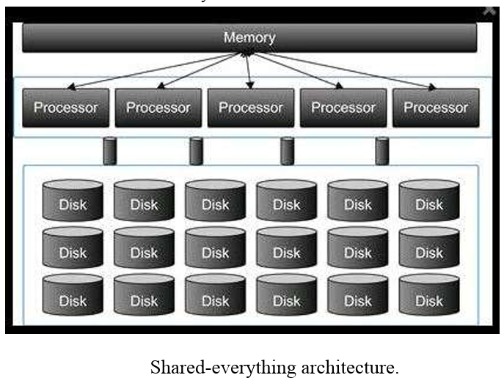

Two variations of shared-everything architecture are symmetric multiprocessing (SMP) and distributed shared memory (DSM)

In the SMP architecture, all the processors share a single pool of memory for read–write access concurrently and uniformly without latency. Sometimes this is referred to as uniform memory access (UMA) architecture. The drawback of SMP architecture is when multiple processors are present and share a single system bus, which results in choking of the bandwidth for simultaneous memory access, therefore, the scalability of such system is very limited.

The DSM architecture addresses the scalability problem by providing multiple pools of memory for processors to use. In the DSM architecture, the latency to access memory depends on the relative distances of the processors and their dedicated memory pools. This architecture is also referred to as nonuniform memory access (NUMA) architecture

Advantages:

1. Centralized Management: Centralized resource management simplifies administration, maintenance, and resource allocation across the system.
2. Data Sharing: Enables seamless data sharing and collaboration among nodes, allowing concurrent access to shared datasets without data replication.
3. Data Consistency: Ensures data consistency and integrity, as all nodes operate on a centralized source of truth for data storage and processing.
4. Resource Utilization: Efficient resource utilization, as nodes can dynamically access shared resources based on workload demands, optimizing resource allocation.
5. Scalability: Offers vertical scalability by adding more resources to the shared pool, supporting larger datasets and more demanding workloads.

Disadvantages:

1. Scalability Constraints: May face scalability constraints due to limitations in vertical scaling, hardware limitations, or contention for shared resources.
2. Single Point of Failure: Centralized resources pose a single point of failure risk, as a failure in the shared infrastructure can impact all nodes in the system.
3. Performance Bottlenecks: Potential performance bottlenecks can occur under heavy concurrent workloads or when handling large-scale data processing tasks.
4. Complexity in Management: Complexity in managing shared resources, coordinating access, and ensuring data consistency can increase management overhead.
5. Cost Considerations: Centralized infrastructure and resource scaling may be costlier compared to shared-nothing architectures, especially for large-scale deployments.

**Use Cases**:

* Database Systems: Shared-everything architectures are commonly used in shared database systems where multiple nodes access a centralized database for data storage, retrieval, and processing. Examples include relational database management systems (RDBMS) like Oracle RAC (Real Application Clusters).
* Real-Time Analytics: For real-time analytics and streaming data processing, shared-everything architectures enable concurrent access to shared data streams, supporting continuous data analysis, event processing, and decision-making.
* Collaborative Workflows: Shared-everything architectures are suitable for collaborative workflows and applications that require multiple nodes to access and work on shared datasets simultaneously, such as collaborative data analysis, research projects, and shared analytics platforms.

**Shared Nothing architecture**

Shared-nothing architecture is a distributed computing architecture commonly used in Big Data processing systems to handle large volumes of data across multiple nodes or servers. In a shared-nothing architecture, each node in the system operates independently and does not share memory, storage, or processing resources with other nodes. This design allows for horizontal scalability, fault tolerance, and efficient parallel processing of data. Let's break down the key characteristics and components of shared-nothing architecture for Big Data:

1. **Node Independence**:
   * Each node in the shared-nothing architecture operates independently and has its own dedicated resources, including CPU, memory, and storage.
   * Nodes do not share resources directly with each other, reducing contention and bottlenecks and allowing for better scalability.
2. **Horizontal Scalability**:
   * Shared-nothing architectures support horizontal scalability, where additional nodes can be added to the system to increase processing power and storage capacity.
   * Scaling horizontally involves distributing data and workload across multiple nodes, allowing the system to handle larger datasets and higher workloads effectively.
3. **Data Partitioning**:
   * Data is partitioned or sharded across nodes in the system, with each node responsible for a subset of the data.
   * Partitioning can be based on different criteria such as key ranges, hashing, or data distribution policies, ensuring balanced data distribution and workload distribution among nodes.
4. **Fault Tolerance**:
   * Shared-nothing architectures are inherently fault-tolerant because a failure in one node does not affect the operation of other nodes.
   * Redundancy and replication strategies are often employed to ensure data durability and availability, with data replicated across multiple nodes for resilience against node failures.
5. **Parallel Processing**:
   * Data processing tasks can be parallelized across multiple nodes, with each node processing its portion of the data independently.
   * Parallel processing improves the overall throughput and reduces processing time, especially for tasks that can be divided into smaller, parallelizable units of work.
6. **Inter-Node Communication**:
   * Nodes in a shared-nothing architecture communicate with each other using a communication layer or messaging framework.
   * Communication protocols such as TCP/IP, RPC (Remote Procedure Call), or messaging queues facilitate data exchange, coordination, and synchronization among nodes.
7. **Examples of Shared-Nothing Architectures**:
   * Hadoop Distributed File System (HDFS) and MapReduce: Hadoop's distributed storage (HDFS) and processing framework (MapReduce) follow a shared-nothing architecture, with data partitioned across HDFS nodes and MapReduce tasks executed in parallel on data nodes.
   * Apache Cassandra: Cassandra is a distributed NoSQL database that employs a shared-nothing architecture, with data partitioned across nodes using a partitioning key and replication strategies for fault tolerance.

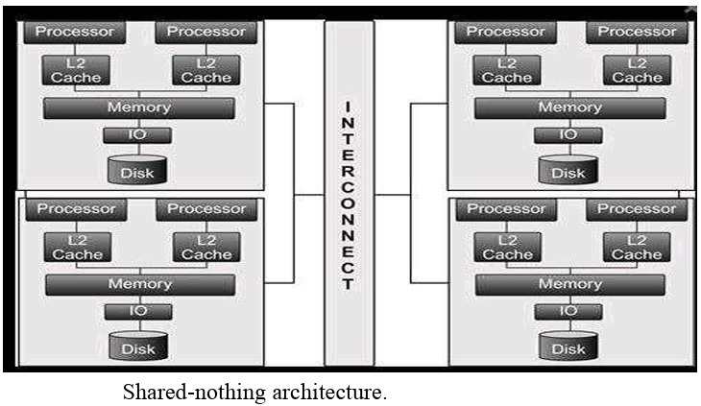

Advantages:

1. Scalability: Easily scalable by adding more nodes to the system, allowing for horizontal scalability without major disruptions.
2. Fault Tolerance: Offers inherent fault tolerance, as a failure in one node does not impact the operation of other nodes.
3. Performance: Parallel processing capabilities enable high performance and faster data processing for large-scale analytics tasks.
4. Flexibility: Each node operates independently, providing flexibility in resource allocation, workload management, and data partitioning.
5. Cost-Effective: Can be cost-effective for distributed computing environments, as it utilizes commodity hardware and scales horizontally as needed.

Disadvantages:

1. Data Transfer Overhead: Data partitioning and distribution among nodes can introduce overhead in data transfer and communication.
2. Complexity: Requires careful data partitioning strategies, load balancing, and coordination mechanisms, adding complexity to system design and management.
3. Limited Centralized Resources: Lack of centralized resources can lead to resource contention and performance bottlenecks under heavy workloads.
4. Scalability Limits: May face scalability limits in extremely large-scale deployments or when handling massive concurrent data processing tasks.

**Use Cases**:

* Batch Processing: Shared-nothing architectures excel in batch processing scenarios where data is processed in parallel across distributed nodes, such as ETL (Extract, Transform, Load) operations, data cleansing, and aggregation tasks.
* Scalable Analytics: For analytics workloads that require scalability, fault tolerance, and parallel processing capabilities, shared-nothing architectures are ideal. Examples include data warehousing, big data analytics platforms, and distributed computing frameworks like Hadoop and Spark.

**Data warehouse**

A data warehouse is a central repository of integrated and structured data collected from various sources within an organization. It is designed to facilitate data analysis, reporting, and decision-making processes by providing a consolidated view of historical and current data. Data warehouses are essential components of business intelligence (BI) and analytics systems, enabling organizations to derive valuable insights and trends from their data. Here are the key components and functions of a data warehouse:

1. **Components of Data Warehouse**:
   * **Data Sources**: These are the systems or sources from which data is extracted and loaded into the data warehouse. Sources may include transactional databases, CRM systems, ERP systems, flat files, and external data sources.
   * **ETL (Extract, Transform, Load) Process**: ETL processes involve extracting data from source systems, transforming it to meet the data warehouse schema and quality standards, and loading it into the data warehouse. ETL tools automate these processes.
   * **Data Warehouse Database**: The core component of a data warehouse is the database where data is stored in a structured, optimized format for analytical queries. The data warehouse database is typically designed using dimensional modeling techniques (e.g., star schema or snowflake schema) to support efficient querying and analysis.
   * **Metadata Repository**: Metadata refers to data about data, such as data definitions, data lineage, data transformations, and data quality information. The metadata repository in a data warehouse stores and manages metadata to facilitate data governance, documentation, and understanding of the data assets.
   * **Business Intelligence Tools**: Data warehouses are often integrated with BI tools such as reporting tools, OLAP (Online Analytical Processing) tools, data visualization tools, and dashboards. These tools enable users to access, analyze, and visualize data from the data warehouse to gain insights and make informed decisions.
2. **Functions of Data Warehouse**:
   * **Data Integration**: Data warehouses integrate data from multiple sources into a unified and consistent format. This integration process involves data cleansing, transformation, and harmonization to ensure data quality and consistency.
   * **Data Storage**: Data warehouses store large volumes of historical and current data in a structured manner optimized for analytics and reporting. The data is organized into dimensions (e.g., time, product, customer) and facts (numeric measures or metrics).
   * **Data Modeling**: Data warehouses use dimensional modeling techniques to design schemas that facilitate efficient querying and analysis. Common modeling techniques include star schema, snowflake schema, and fact constellation schema.
   * **Data Access and Querying**: Data warehouses provide tools and interfaces for users to access and query data using SQL (Structured Query Language) or OLAP queries. Users can perform ad-hoc queries, generate reports, and create interactive visualizations to explore data and uncover insights.
   * **Data Transformation and Aggregation**: Data warehouses support data transformation operations to derive derived attributes, calculated measures, aggregates, and summaries for analytical purposes. Aggregation functions enable faster querying and analysis of large datasets.
   * **Data Governance and Security**: Data warehouses enforce data governance policies, access controls, and security measures to protect sensitive data, ensure data privacy, and comply with regulatory requirements (e.g., GDPR, HIPAA).
   * **Business Intelligence and Analytics**: Data warehouses serve as the foundation for business intelligence and analytics initiatives, providing the data infrastructure and capabilities for descriptive, diagnostic, predictive, and prescriptive analytics. BI tools leverage data warehouse data to generate insights, identify trends, monitor KPIs, and support decision-making processes.

**Advantages:**

1. Centralized data repository for integrated and historical data.
2. Improved data quality through cleansing and transformation.
3. Supports business intelligence and advanced analytics.
4. Enhanced performance for analytical queries.
5. Retains historical data for trend analysis and forecasting.
6. Scalable to accommodate growing data volumes and user needs.

**Disadvantages:**

1. Complex and costly to build and maintain.
2. Data latency issues may arise.
3. Rigid schema design can be inflexible.
4. Challenges with data governance and security.
5. Limited support for unstructured data.
6. Scalability constraints in large-scale deployments.

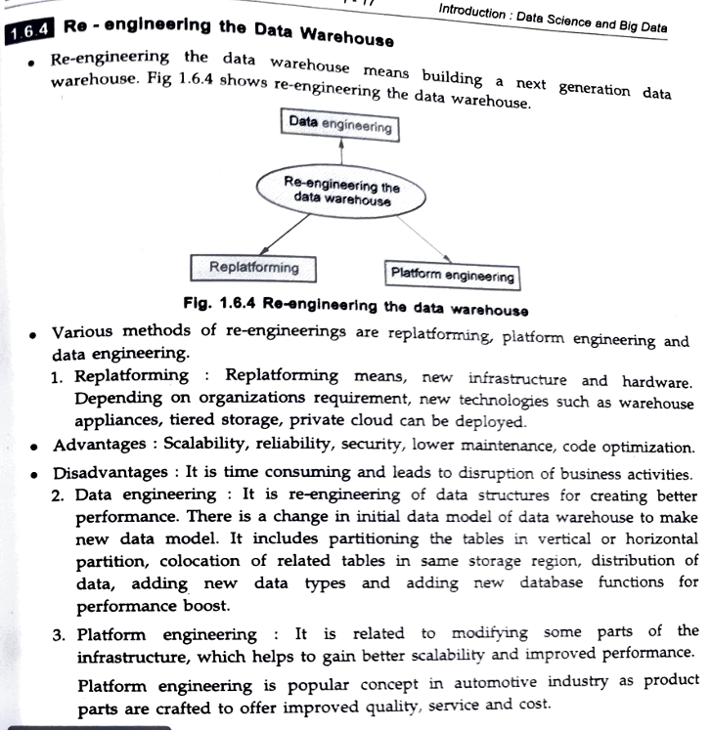

**What are ihe pitfalls of data warehouse? Why companies are shifting to Big Data using Hadoop.**

**Pitfalls of Data Warehouses:**

1. **Scalability Challenges:** Traditional data warehouses may face scalability challenges when dealing with large volumes of data. Scaling up can be expensive, and scaling out may require complex architectural changes.
2. **Cost and Complexity:** Building and maintaining a data warehouse can be costly and complex. It involves significant investments in hardware, software, skilled personnel, and ongoing maintenance.
3. **Rigid Schema Design:** Data warehouses often use rigid schemas, making it difficult to accommodate changes in data structures or handle unstructured data effectively.
4. **Data Latency:** Data latency can be a concern in data warehouses, where there may be delays in data processing and availability for analysis, especially for real-time or near-real-time use cases.
5. **Limited Support for Unstructured Data:** Traditional data warehouses are optimized for structured data and may struggle with handling unstructured or semi-structured data types effectively.
6. **Data Governance and Security:** Managing data governance, access controls, and security in a data warehouse environment can be complex and challenging.

**Shift to Big Data Using Hadoop:**

Companies are shifting to Big Data technologies like Hadoop for several reasons:

1. **Scalability:** Hadoop offers horizontal scalability, allowing companies to scale out easily by adding more nodes to the cluster to handle growing data volumes.
2. **Cost-Effectiveness:** Hadoop is often more cost-effective than traditional data warehouses, as it can run on commodity hardware and open-source software, reducing infrastructure costs.
3. **Flexibility with Schema:** Hadoop's distributed file system (HDFS) and flexible schema-on-read approach enable companies to store and process diverse data types, including structured, unstructured, and semi-structured data.
4. **Real-Time and Batch Processing:** Hadoop ecosystem components like Apache Spark, Apache Flink, and Apache Kafka support both real-time and batch processing, addressing data latency concerns and enabling real-time analytics.
5. **Advanced Analytics:** Hadoop enables companies to perform advanced analytics, machine learning, and predictive modeling on large datasets, uncovering valuable insights and driving data-driven decision-making.
6. **Scalable Storage and Processing:** Hadoop's distributed storage and processing capabilities provide scalable and fault-tolerant infrastructure for handling Big Data workloads efficiently.

**Lambda Architecture**:

* **Definition**: Lambda Architecture is a data processing architecture designed to handle both batch and real-time/streaming data processing. It involves using two separate paths for data processing: one for real-time data (streaming path) and another for batch data (batch path).
* **Key Components**:
  + **Batch Layer**: The batch layer is responsible for storing and processing large volumes of historical data. It uses batch processing techniques to perform complex transformations, aggregations, and computations on the entire dataset. The results are stored in a master dataset known as the batch view.
  + **Speed Layer**: The speed layer handles real-time data processing and analytics. It processes incoming data streams in real-time and generates incremental updates to the batch view produced by the batch layer. These updates are merged with the batch view to create a comprehensive view of the data that includes both historical and real-time insights.
  + **Serving Layer**: The serving layer is responsible for serving queries and providing access to the merged views generated by the batch and speed layers. It ensures that users can query and access the most up-to-date and comprehensive data views for their analytical needs.
* **Advantages**:
  + Provides fault tolerance and scalability.
  + Supports both batch and real-time processing.
  + Enables complex analytics on large datasets.
* **Disadvantages**:
  + Complexity in managing and synchronizing batch and real-time views.
  + Potential latency due to batch processing.

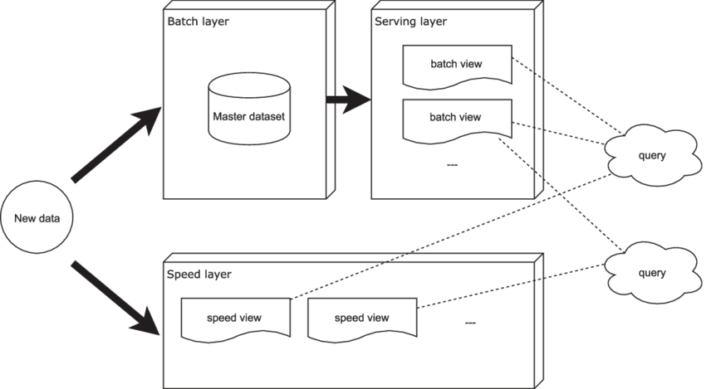

**Lambda**

**Kappa Architecture**:

* **Definition**: Kappa Architecture is a simplified approach to big data processing that focuses solely on real-time/streaming data processing. It eliminates the need for separate batch and speed layers by using a unified processing pipeline for both historical and real-time data.
* **Key Components**:
  + **Stream Processing Layer**: The stream processing layer is responsible for processing real-time data streams as they arrive. It uses stream processing frameworks like Apache Kafka Streams, Apache Flink, or Apache Storm to perform real-time computations, transformations, and analytics on incoming data. The processed data is then stored in a data store optimized for real-time access.
  + **Data Store**: The data store is used to store the processed real-time data generated by the stream processing layer. It can be a distributed database, key-value store, or NoSQL database optimized for high throughput and low latency access.
* **Advantages**:
  + Simplicity and reduced complexity compared to Lambda Architecture.
  + Lower latency as there is no batch processing overhead.
  + Scalability and fault tolerance provided by stream processing frameworks.
* **Disadvantages**:
  + Limited support for complex batch processing and analytics on historical data.
  + Potential challenges in managing and optimizing real-time data stores.

Kappa Architecture

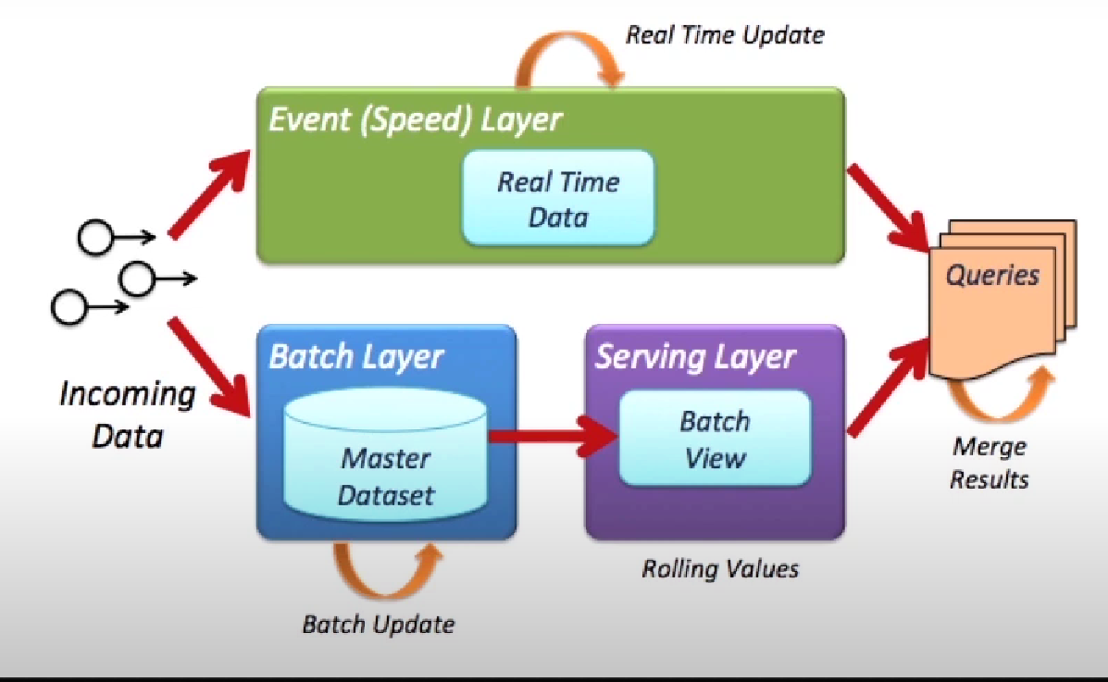

Comparison of Lambda and Kappa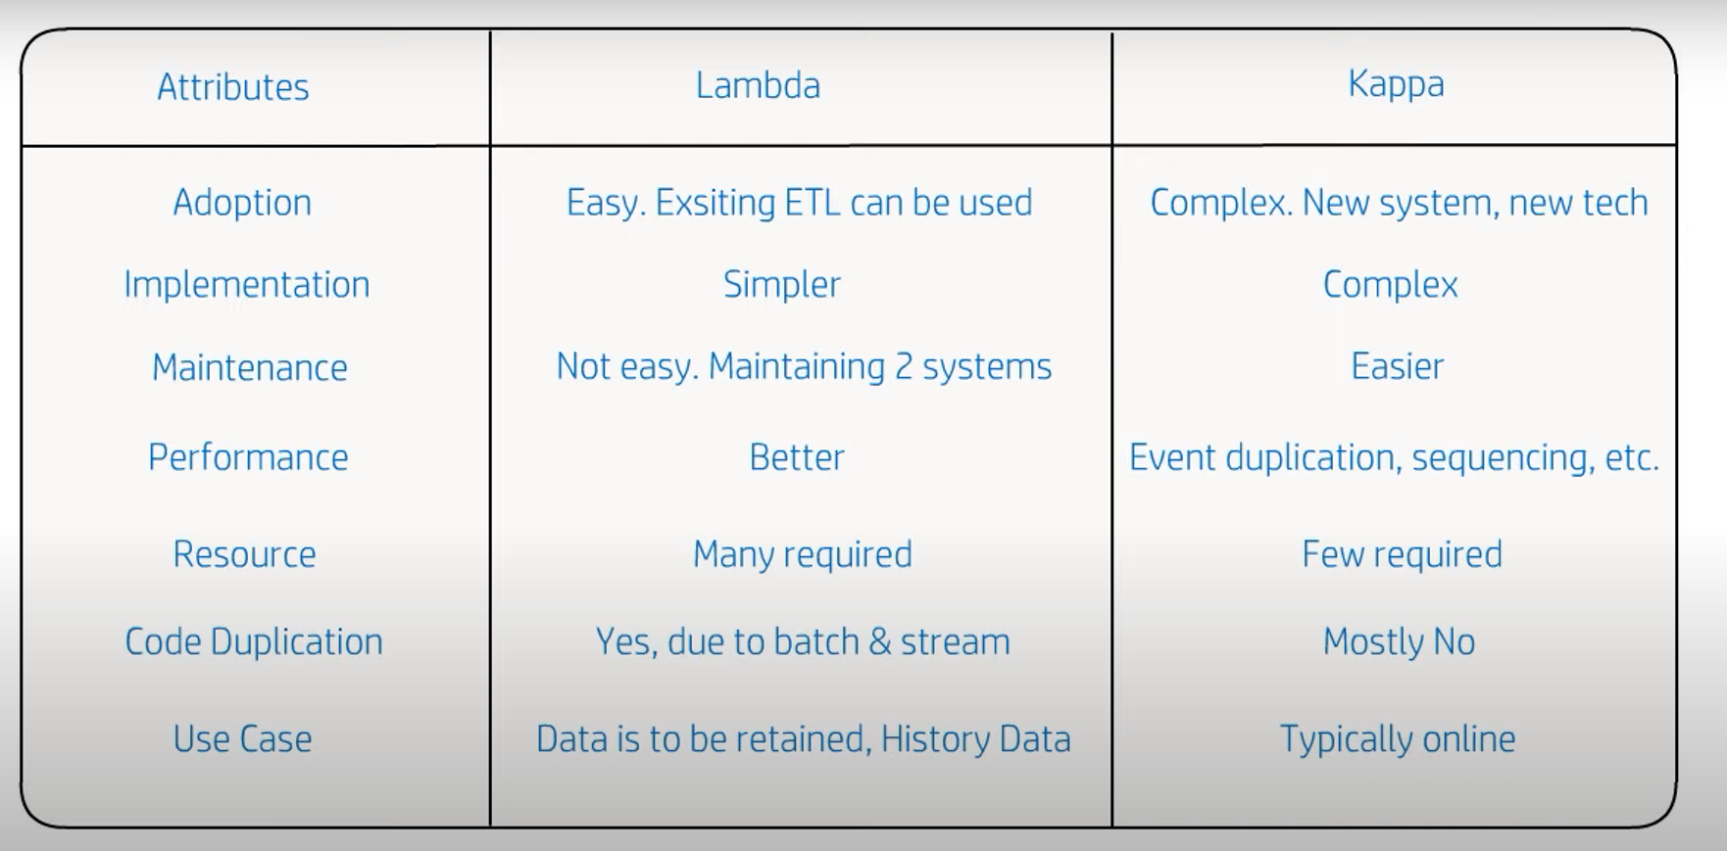

**Draw and explain Big Data Processing Architecture with technologies used at each of the stage of big data processing.**

1. **Data Ingestion**:
   * At this stage, data is collected from various sources such as sensors, social media, logs, databases, etc.
   * **Technologies**: Apache Kafka, Apache NiFi, AWS Kinesis, Google Cloud Pub/Sub.
2. **Data Storage**:
   * Data is stored in a scalable and distributed manner for efficient retrieval and processing.
   * **Technologies**: Hadoop Distributed File System (HDFS), Amazon S3, Google Cloud Storage, Apache HBase, Apache Cassandra.
3. **Data Processing**:
   * Data undergoes processing to extract insights, perform analytics, and generate reports.
   * **Batch Processing Technologies**: Apache Spark, Apache Hadoop (MapReduce), Apache Flink.
   * **Stream Processing Technologies**: Apache Kafka Streams, Apache Storm, Apache Beam.
4. **Data Integration and Orchestration**:
   * Data from multiple sources is integrated, cleansed, and orchestrated for further processing.
   * **Technologies**: Apache Airflow, Apache Oozie, Apache NiFi, AWS Glue, Talend.
5. **Data Analysis and Analytics**:
   * Data is analyzed using various techniques such as machine learning, data mining, and statistical analysis.
   * **Technologies**: Apache Spark (MLlib), TensorFlow, PyTorch, Apache Hive, Apache Pig.
6. **Data Visualization and Reporting**:
   * Insights and findings are visualized through dashboards, charts, and reports.
   * **Technologies**: Tableau, Power BI, Apache Superset, Grafana, Kibana.

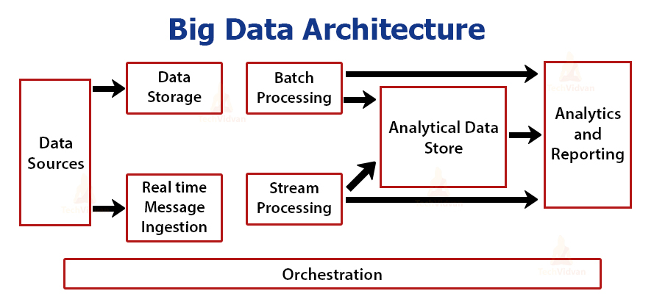

1. **Replatforming:**
   * Replatforming involves migrating or upgrading the underlying technology stack and infrastructure of the data warehouse. This step is crucial in modernizing the data warehouse architecture, improving scalability, performance, and cost-effectiveness.
   * Under the re-engineering process, replatforming can include migrating from on-premises data warehouses to cloud-based solutions, upgrading database management systems (DBMS), adopting new data integration tools, and optimizing hardware resources.
   * Key considerations during replatforming include evaluating cloud providers (e.g., AWS, Azure, Google Cloud), selecting appropriate data warehouse platforms (e.g., Amazon Redshift, Snowflake, Google BigQuery), and implementing data migration strategies with minimal downtime and data loss.
2. **Data Engineering:**
   * Data engineering plays a crucial role in re-engineering the data warehouse, focusing on designing, building, and optimizing data pipelines, ETL processes, data models, and data workflows.
   * Data engineering efforts may include redesigning data schemas, transforming data formats, improving data quality and governance, automating ETL tasks, and integrating new data sources seamlessly.
   * Advanced data engineering techniques such as data partitioning, indexing, data deduplication, data cleansing, and data lineage tracking are applied to enhance data processing efficiency, reduce latency, and ensure data accuracy and consistency.
3. **Platform Engineering:**
   * Platform engineering involves optimizing the data warehouse platform itself, including database performance tuning, query optimization, workload management, and resource allocation.
   * Platform engineering activities may include implementing caching mechanisms, leveraging in-memory processing, optimizing storage configurations, fine-tuning database parameters, and managing concurrency and contention.
   * Platform engineers focus on enhancing system scalability, reliability, availability, and fault tolerance through robust monitoring, alerting, logging, and performance benchmarking practices.

**list and explain data processing infrastructure challenges in big data with suitable example**

1. **Scalability:**
   * **Challenge:** Big data processing infrastructure must scale seamlessly to handle increasing data volumes, user demands, and computational requirements without compromising performance or reliability.
   * **Example:** A social media platform experiences a surge in user activity during a major event, resulting in a massive influx of data such as posts, comments, likes, and shares. The data processing infrastructure needs to scale dynamically to accommodate the spike in workload and ensure timely processing and analysis of user interactions.
2. **Performance:**
   * **Challenge:** Achieving high performance in data processing workflows, including data ingestion, transformation, storage, retrieval, and analytics, to meet real-time or near-real-time processing requirements.
   * **Example:** A financial institution processes large volumes of transactional data in real-time to detect fraudulent activities. The data processing infrastructure must deliver low-latency processing, efficient querying, and accurate anomaly detection algorithms to identify and respond to fraudulent transactions promptly.
3. **Reliability and Fault Tolerance:**
   * **Challenge:** Ensuring the reliability, fault tolerance, and resilience of data processing infrastructure to handle hardware failures, network outages, software errors, and other disruptions without data loss or downtime.
   * **Example:** A cloud-based data processing system utilizes distributed computing and fault-tolerant mechanisms to maintain continuous operations even if individual servers or components experience failures. Data redundancy, replication, and automated failover mechanisms are implemented to ensure reliability and data integrity.
4. **Cost Management:**
   * **Challenge:** Managing the costs associated with big data processing infrastructure, including hardware resources, software licenses, cloud services, data storage, data transfer, and ongoing maintenance and support.
   * **Example:** An e-commerce company analyzes customer behavior and purchase patterns to personalize recommendations and marketing campaigns. The data processing infrastructure optimizes resource utilization, uses cost-effective storage solutions (e.g., object storage), leverages serverless computing for on-demand scalability, and implements data lifecycle management policies to reduce storage costs for historical data.
5. **Complexity and Integration:**
   * **Challenge:** Dealing with the complexity of integrating diverse data sources, data formats, data processing tools, and analytics frameworks within a unified data processing infrastructure.
   * **Example:** A healthcare organization collects data from electronic health records (EHRs), medical devices, wearables, and patient portals for clinical analytics and research. The data processing infrastructure integrates structured and unstructured data, applies data transformation and cleansing workflows, ensures data privacy and security compliance (e.g., HIPAA), and supports interoperability standards for seamless data exchange between healthcare systems.
6. **Data Governance and Security:**
   * **Challenge:** Implementing robust data governance policies, data quality controls, access controls, encryption, authentication, auditing, and compliance measures to protect sensitive data, ensure data privacy, and maintain regulatory compliance.
   * **Example:** A financial services firm processes sensitive customer financial data for risk analysis, regulatory reporting, and compliance monitoring. The data processing infrastructure implements encryption for data at rest and in transit, enforces access controls based on role-based permissions, conducts regular security audits and penetration testing, and complies with industry regulations such as GDPR, PCI DSS, and SOX.

